Chapter 3

**PROJECT methodology**

This chapter discusses the development of the proposed study which includes the software development methodology, the scope and delimitations, the data gathering techniques, and the sources of data.

**Software Development Methodology**

In the design and development of the proposed system, entitled “Web-Based Barangay Information System” for Barangay Zone 1 in the Municipality of Bulan Sorsogon. This system can process the files of the barangay which provide efficient way of storing the barangay information. The researcher will be using the Rational Unified Process as the methodology model in developing the system. The Rational Unified Process enhances team productivity, by providing every team member a knowledge and serves as guide for the development of the project.

Figure 2.1 illustrates the overall architecture of RUP. This figure shows the lifecycle concept of RUP.

|  |
| --- |
|  |
|  |  |

Figure 2.1 RUP Four Phases

The following are the phases of Rational Unified Process (RUP).

3.1 RUP Lifecycle

The RUP has four phases which are Inception, Elaboration, Construction, and Transition. Each of these phases plays an important role in managing and for the development of the projects by using RUP. Each phase includes with a major milestone, as shown in figure 2.1.

3.2. Inception Phase

During the inception phase, my team determined the basic idea about what project were going to do and who is the client that would benefit for this project and what is the hardware and software requirements needed for this system. The team will decide if this project worth pursuing and it used to prepare the necessary measures need for stablishing the system, including planning, outlining the project, and design. Determined how much the estimated cost and what is the resources needed to complete this project.

The Lifecycle Objectives Milestone of Inception phase is the following evaluation criteria:

* Determine the projects scope and boundaries
* Client Approval of the proposed project
* How much the estimated cost
* Risk of the development process
* Identify the use cases of the system
* Identify the hardware and software requirements

The inception phase is concluded by the lifecycle objective milestone. During this point, the lifecycle objective of the project is examined which my team decided either to proceed the or to cancel.

3.3 Elaboration Phase

Elaboration phase captures the functional requirements of the system. The main goal of the elaboration is to show the architecture of the system in the form of (use cases, system flow chart, class diagram, etc..), it’s helps as to provide a stable basis for the design and implementation effort in the construction phase. Elaboration phase objectives is the following:

* Establish the architecture and requirements
* Establish a supportive environment
* Address all architecturally important risks
* Build a baseline architecture that will be used for the entire project

The Elaboration phase is concluded by the Lifecycle Architecture Milestone. During this phase my group team is determine the system requirements that needed for the construction of the project.

3.4 Construction Phase

Construction Phase is starting of building the project and most of the coding is created. The system will develop using the baseline establish in the elaboration phase. Construction phase objectives is the following listed:

* Fully completed system
* Complete the analysis, design, development, and testing
* User Manual

The Construction Phase is concluded by the Initial Operation Capability Milestone. During this point my team is decided if the system that build by our system engineer is ready to go operation. The evaluation criteria that we use for construction phase is answering the following listed:

* Is this system being ready to release and stable?
* Is this system ready to be deployed in user community?

3.5 Transition Phase

The Transition Phase is moving the system into the user’s environment. The goal of this transition phase is to make sure that the system is ready to be used. Transition phase objectives is the following:

* Product testing and Evaluation
* Validate the new system against user expectations
* Trained the users

The Transition Phase is concluded by the Product Release Milestone. During this point my team making sure that the product is ready for the customer to be used and ready for the final evaluation. At this point the developers will completely developing the system and before it can release to the client, the proponents and developers conduct a several testing and evaluation that support and relevant to the system to meets the needs of the respondents. To evaluate the system the proponents used the ISO 25010 evaluation tools, the proponents identified the 2 group of users to evaluate the system. The first group was composed 2 IT experts and second group was composed of end-user. (2) IT Experts is coming from Sorsogon State University which helped the researcher to identify if meets the user requirement and satisfaction, the user interface design, as well as to test the system reliability, efficiency, and functionality of the developed system.

**Scope and Delimitations of the Study**

The scope of this system is to provide an efficient and accurate Barangay Information System. It involved a database that store the data where in the Barangay Official that will assigned to manage and monitor the records of the residents. It also focused on securing the confidential records of the barangay. The development of this system will help the barangay official assigned to perform many operations such as add, update, delete and store data. It also performed the process of records complaints wherein it views and make actions to the solved and unsolved cases in the barangay. It can easily generate exports records of the residents into excel, it can create a clearance forms and issuances of barangay certificates. Lastly this system requires internet connection to work properly.

However, the limitations of this system are: It cannot perform the other operations such as the economy of barangay, it cannot open offline, the residents cannot access the system only authorized user can access and the administrator is the only one who assigned a barangay official user, the system cannot share data to other databases and lastly it limits the other transactions within the other barangay because it only intended for the barangay zone 1 bulan Sorsogon.

**Data Gathering Techniques**

The researcher used the following techniques for data gathering.

Interview**.** One of the most widely used data gathering technique that allows building a deeper understanding of the study. It covers several advantages on the side of the researchers like (1) Deeper insight of the study, (2) Accuracy of answers through correct interpretation of the questions, and (3) Physical presence improve the persistency and response rate. The proponents will be using the interview as a tool to gather some relevant information that needs to be in this study. The proponents will conduct interview to the barangay including the barangay captain, barangay workers, and the assigned staff about the processing of issuing barangay clearances, issuing business permit, issuing barangay indigency, managing resident’s records, barangay official record, barangay cases and other barangay services.

Document Analysis**.** It consists of examining existing data in the form of databases, meeting minutes, reports, attendance logs, publications etc.; an inexpensive way to gathering information which is useful for development of the study. <<you can replace this technique or provide additional definition>>.

Survey**.** It enables the researcher to obtain information by using survey forms (includes list of survey guide questions or evaluation) to the respondents. It is a form of inquiry document, which contains a systematically compiled and well-organized series of survey questions intended to elicit the information for statistical analysis. The proponents will provide a survey to the users it is used to know what we can improve to our system, and they are allowed to give us feedback of what is the user experiences or write what are the needs and don’t to the system made by the developer. In this study we applied the ISO/IEC 25010 for conducting a survey to the respondents and McCall’s questionnaire software characteristics which tested and evaluated the system. It will be used to describe the functionality of the study based on its components and criteria in terms of Accuracy, Reliability, Usability, Efficiency and User Friendly.

# Sources of Data

In this section you can present the sources of your data. You can discuss various offices, company, establishment, organization, institution and etc., to whom you will gather your needed data. Discussion of sources of data should be in general form and no personality should be named in accordance to data privacy law.

**Figure 1 Use - Case Diagram of the Barangay Information System**

**3.6 Use Case Diagram**

In Figure 1 shows the Use Case Diagram that shows the two (2) main actors of the system which is the Barangay Chairman and Barangay Secretary it shows the role of each actor on the Barangay Information System. The Barangay Chairman is the system administrator who manages the entire functionality of the system, and The Barangay Secretary will in-charge of the process of encoding, recording of the barangay resident’s information, issuing the approved barangay certificates, complaints, and barangay activities.

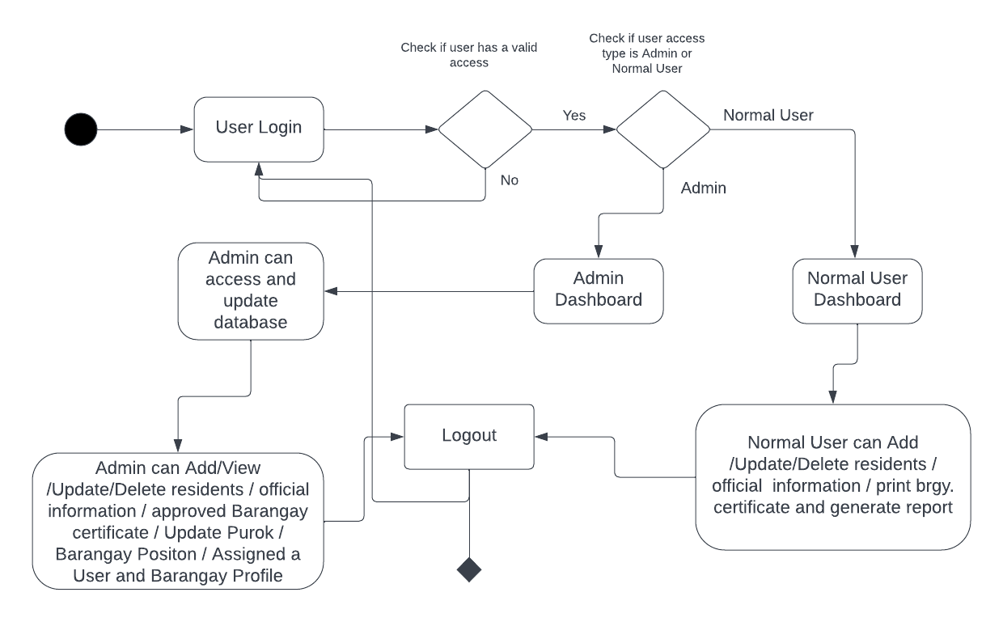

**Figure 2 Activity Diagram of the Barangay Information System**

**3.7 Activity Diagram**

In Figure 2 shows the Activity Diagram basically it shows the system flowchart that describe the operation of the system on how the user can enter to the system and the password and username is the only requirements to be login to the system, at first the user will try to login using there username and password and it will check if the user is administrator or normal user then if the user have access he will redirect to the admin dashboard or in normal user dashboard and if the user don’t have account he/she will go back to the login form.

**Figure 3 Administrator’s System Flow Chart**

**3.8 Administrator’s System Flow Chart**

In thisFigure 3.4 show the flow of system. The system lets the administrator input username and password if it registered, he/she will redirect to the dashboard, and it will load all the module and operations of administrator in the system. The administrator has the authority to access the entire operations of the system including system sittings and assigned the role of the user if admin or staff.

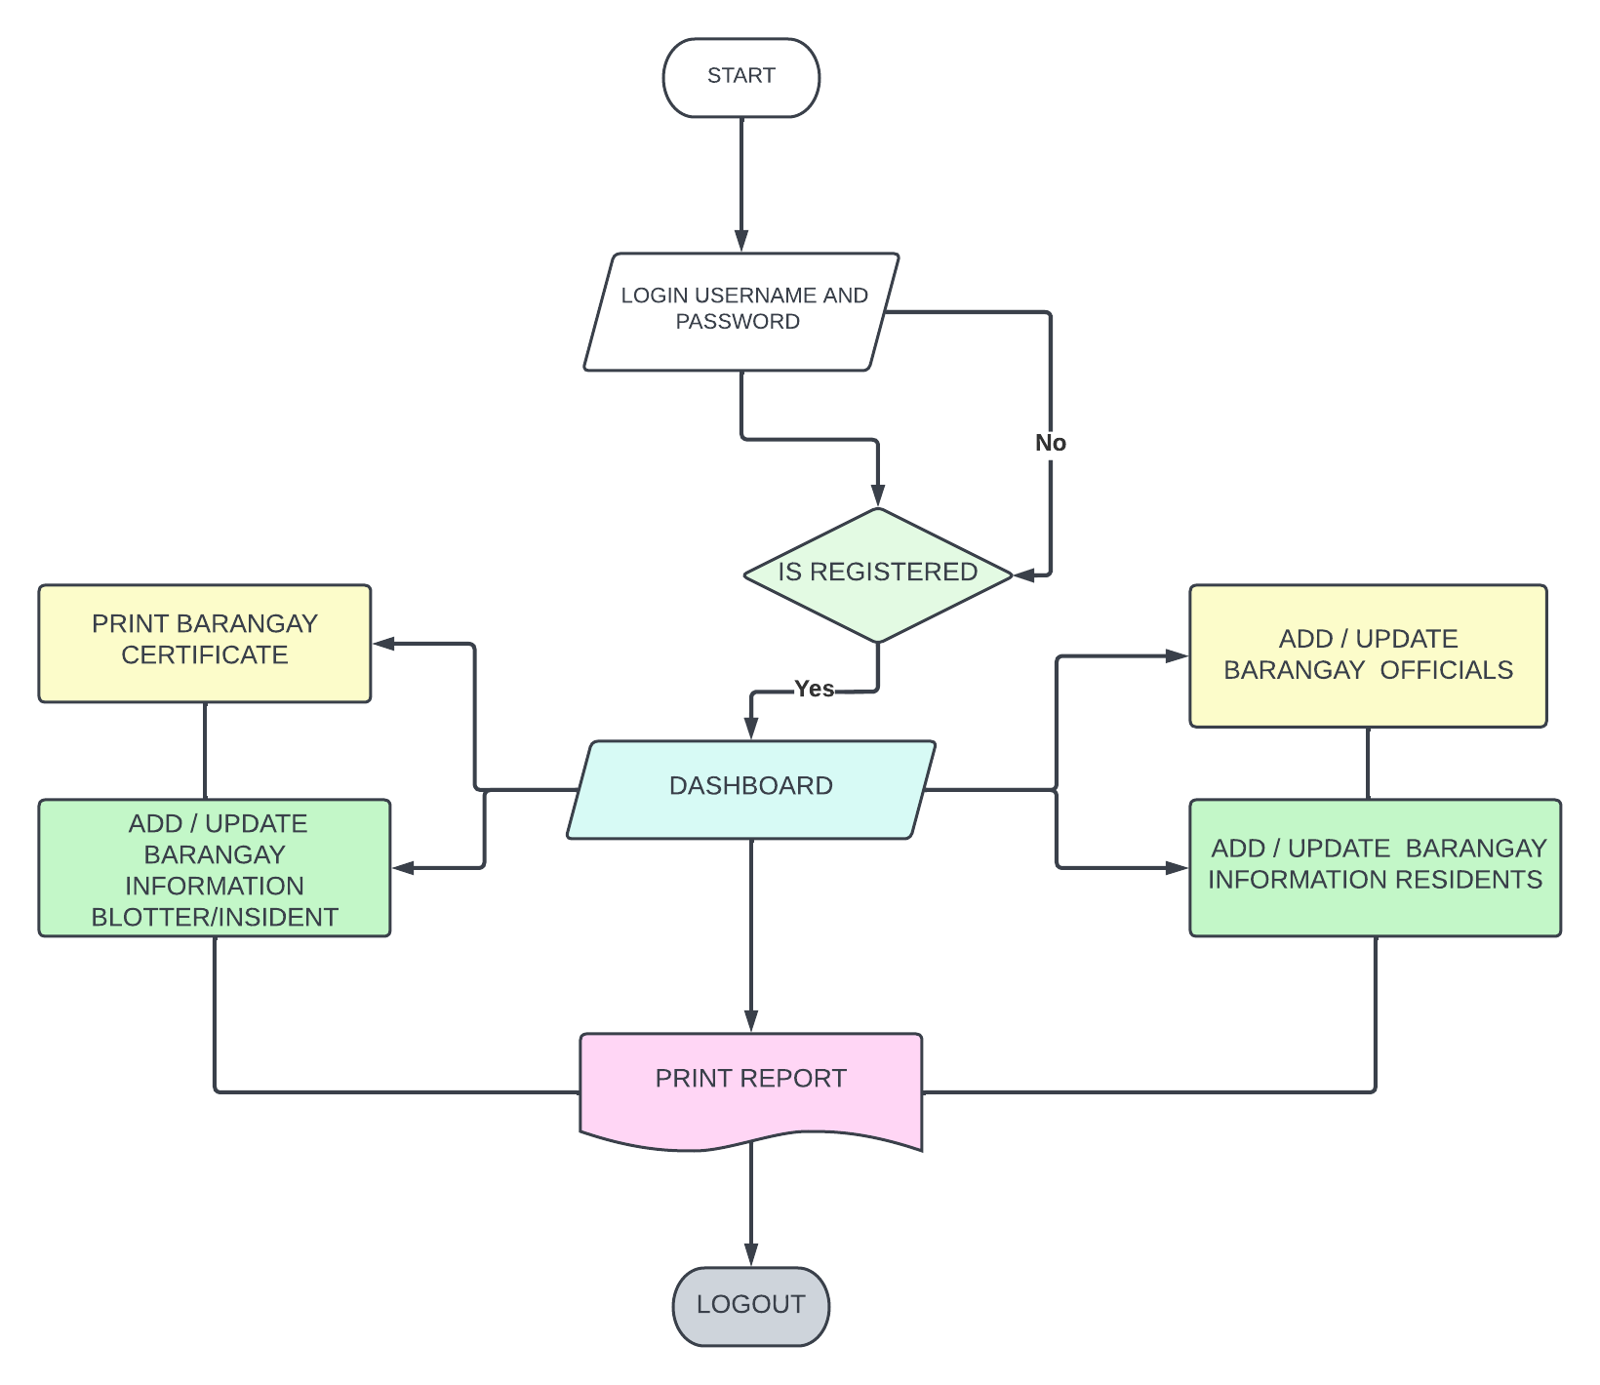

**Figure 4 Normal User System Flow Chart**

**3.9** **Normal User System Flow Chart**

Figure 4 shows the normal user flow chart it can be a secretary of the barangay or any barangay official’s that assigned by administrator to help some barangay paper works. The system lets the normal user to input username and password, it should be validated based on data from the database, it will check the user privilege if the username and password is exist then if has found, it loads the Normal user dashboard and the basic operation which are add/update barangay official, add/update barangay residents, manage barangay blotter/incident, print reports.

**4.1 UML CLASS DIAGRAM**

Figure 5 on the next page shows the relationship of different classes of the barangay information system. The User, Barangay profile info, resident, brgy: official’s, position, purok, payments, blotter, and permit are included in this class diagram. This diagram determines the process of the system and functions that was relevant to the system. This class diagram used to describe the structure of the system by showing its classes, attributes, and operations. It was generated from entity relationship diagram of the system database**.**

**Figure 5 UML Class Diagram**

The respondents of the study are the personnel of <<write your client>>. Table # summarizes the number of respondents.

Table 1

Summary of Respondents

|  |  |
| --- | --- |
| **Respondents** | **No. of Respondents** |
| *Job Title (ex. Administration Staff)* | *#* |
| *Job Title* | *#* |
| *Job Title* | *#* |
| **Total** | **#** |

Provide discussion for the above table.